**PRACTICAL INTERVIEW**

1. Implement/design below page with css(don’t use bootstrap) and React-Redux. Make fake api calls with waiting of 2-3 seconds and after that return hardcoded data. Page design should be mobile friendly.

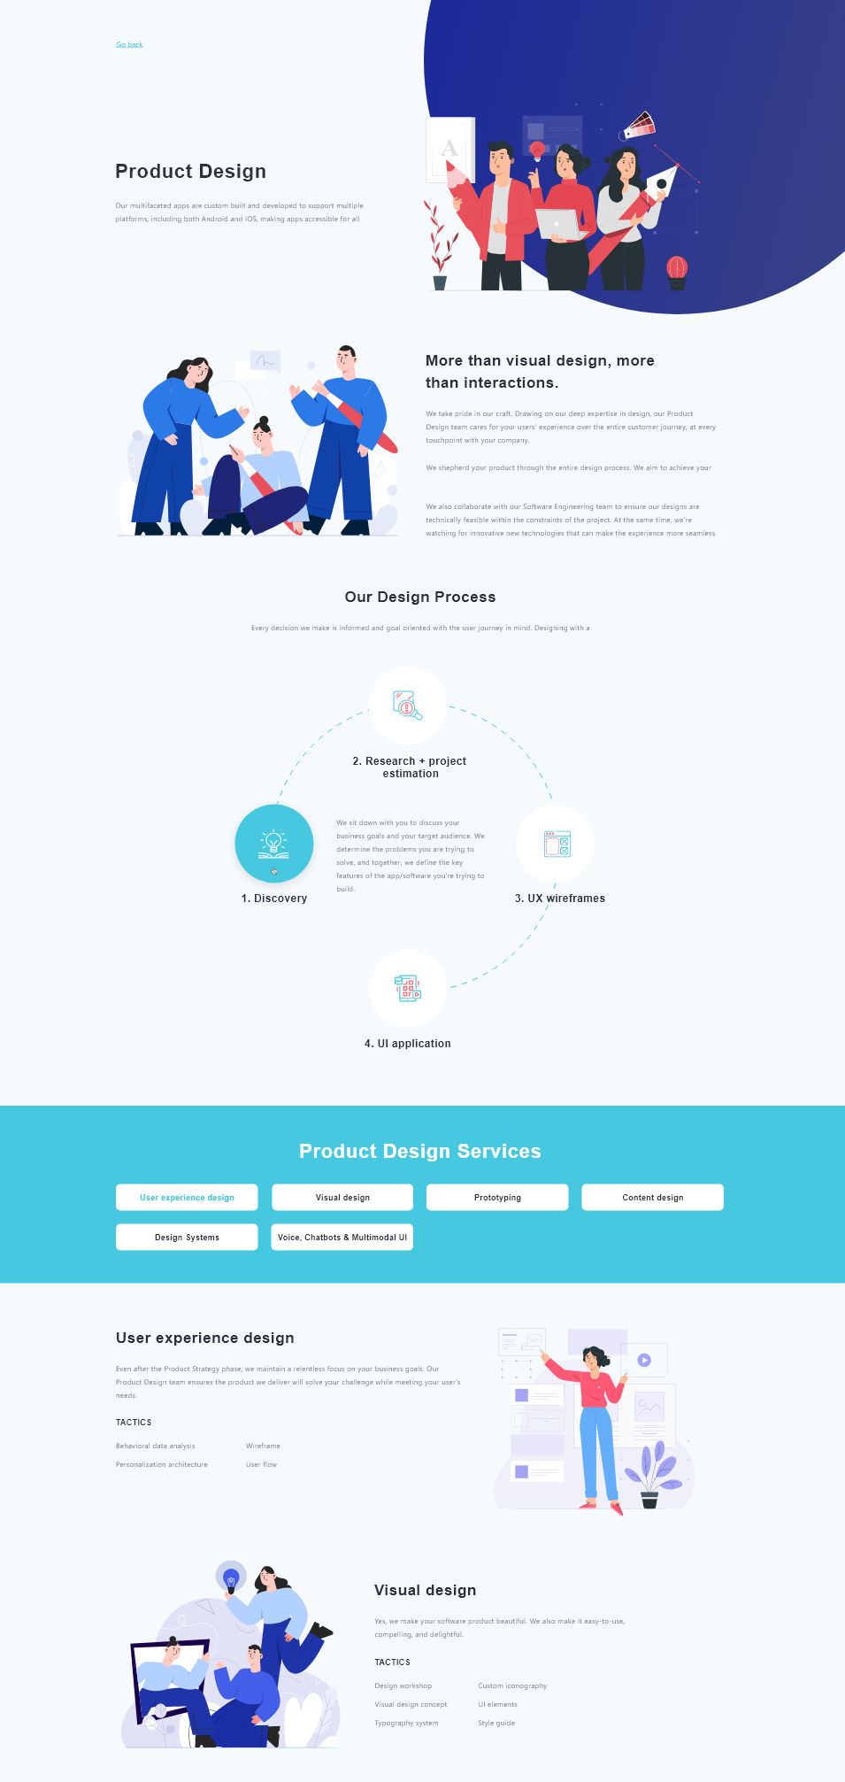

1. Implement a second page where same header design will take place but only data(title, description, image) will get changed. Implement navigation from first page to this page.



1. Implement a control to add more than one text field by clicking "+" button. and can tell him to make the fake(just delayed response) api call to post this data.
2. Implement a form(No design needed) to add/edit data. It is good if you can use all the form controls.